**EXERCISE 6**-**CURSORS**

**SCENARIO 1:** **GenerateMonthlyStatements**

**PROCEDURE:**

DECLARE

CURSOR GenerateMonthlyStatements IS

SELECT t.TransactionID, t.AccountID, t.Amount, t.TransactionType, t.TransactionDate, c.Name

FROM Transactions t

JOIN Accounts a ON t.AccountID = a.AccountID

JOIN Customers c ON a.CustomerID = c.CustomerID

WHERE TRUNC(t.TransactionDate, 'MM') = TRUNC(SYSDATE, 'MM');

BEGIN

FOR rec IN GenerateMonthlyStatements LOOP

DBMS_OUTPUT.PUT_LINE('Customer: ' || rec.Name ||

' | Transaction ID: ' || rec.TransactionID ||

' | ' || rec.TransactionType || ' of $' || rec.Amount ||

' on ' || TO_CHAR(rec.TransactionDate,'DD-MON-YYYY')

);

END LOOP;

END;

**/ OUTPUT:**

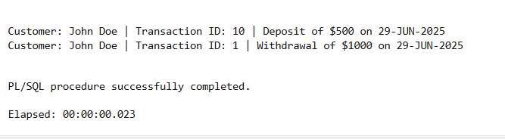

**SCENARIO 2: ApplyAnnualFee**

**PROCEDURE:**

DECLARE

CURSOR ApplyAnnualFee IS

SELECT AccountID, Balance

FROM Accounts;

BEGIN

FOR rec IN ApplyAnnualFee LOOP

UPDATE Accounts

SET Balance = Balance - 100 -- flat $100 annual fee

WHERE AccountID = rec.AccountID;

DBMS_OUTPUT.PUT_LINE('Annual fee applied to Account ID ' || rec.AccountID ||

'. New balance: $' || (rec.Balance - 100));

END LOOP;

COMMIT;

END;

/

**OUTPUT:**

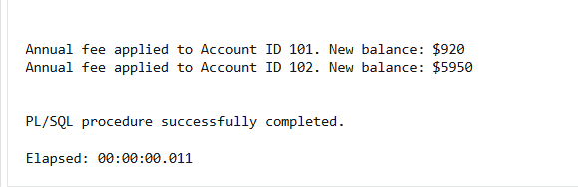

**SCENARIO 3:UpdateLoanInterestRates**

DECLARE

CURSOR UpdateLoanInterestRates IS

SELECT LoanID, InterestRate

FROM Loans;

BEGIN

FOR rec IN UpdateLoanInterestRates LOOP

IF rec.InterestRate > 6 THEN

UPDATE Loans

SET InterestRate = InterestRate - 1

WHERE LoanID = rec.LoanID;

DBMS_OUTPUT.PUT_LINE('Loan ID ' || rec.LoanID ||

' interest reduced to ' || (rec.InterestRate - 1) || '%');

ELSE

UPDATE Loans

SET InterestRate = InterestRate + 0.5

WHERE LoanID = rec.LoanID;

DBMS_OUTPUT.PUT_LINE('Loan ID ' || rec.LoanID ||

' interest increased to ' || (rec.InterestRate + 0.5) || '%');

END IF;

END LOOP;

COMMIT;

END;

/

**OUTPUT:**

